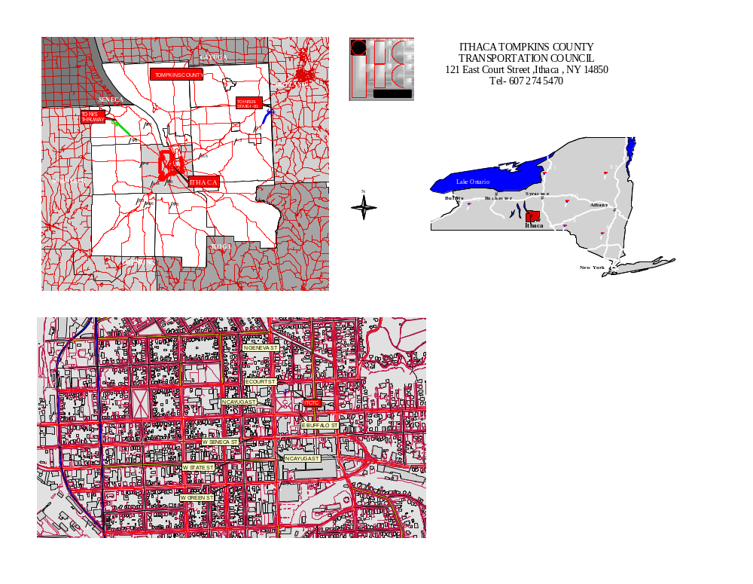
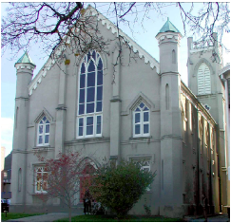
- FROM POINTS NORTH: South on I-81.
- Exit 12 at Cortland/Homer.
- Rte. 281 South to State Rte. 13.
- South on State Rte. 13 to Ithaca, NY.
- Turn east on Court St to 121 E. Court St.
- FROM POINTS EAST:
- West on I-90 (NY State Thruway) to I-88.
- West on I-88 for 76 miles to Exit 8 for State Rte. 206 at Bainbridge, NY.
- West on State Rte. 206 for 25 miles to State Rte. 79 at Whitney Point, NY
- West on State Rte. 79 for 35 miles to Ithaca, NY
- Turn right on Cayuga St.
- Turn right on Court St. to 121 E. Court St.
- FROM POINTS SOUTH (Binghamton):
- North on I-81 to Exit 8 for Whitney Point, NY.
- West on State Rte. 79 for 35 miles to Ithaca, NY.
- Rte. 79 West will bring you into Ithaca on State St
- Right on Aurora and left on Court St.

- FROM POINTS SOUTH (Elmira)
- North on State Rte. 13 to Ithaca, NY.
- Turn right on Court St. to 121 E. Court St.

- FROM POINTS WEST: East on I-90 (NY State Thruway) to Exit 42.
- South on Rte. 14 for approximately one-quarter mile to Rte. 96.
- South on Rte. 96 for approximately 45 miles to Ithaca, NY.
- North on Rte. 13 to Court St.
- Turn east on Court St. to 121 E. Court St

