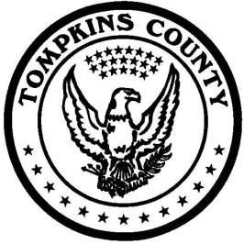

Tompkins County Office of Human Rights

120 Martin Luther King, Jr. / W. State Street
Ithaca, New York 14850
Tel: 607.277.4080 Fax: 607.277.4106

Inclusion Through Diversity

SAVE THE DATES MEMO

TO: School Administrators, Teachers, and other Human Rights Enthusiasts
FROM: Karen Baer, Tompkins County Office of Human Rights
DATE: 3 July 2017
RE: Save the Date/Program Announcement

30th Annual Human Rights Arts Competition (K-12)

Please save the dates for the 30th Annual Human Rights Arts Competition (K-12) sponsored by the Tompkins County Office of Human.

Important Timeline
Entries Accepted Starting: Friday, September 8, 2017
Deadline for Submissions: Friday, November 24, 2017
Winners Announced: Friday, December 1, 2017
Awards Ceremony: Saturday, December 9, 2017 (Int'l Human Rights Day)
Tompkins County Public Library, Avenue of Friends, 11 a.m.

Competition Categories
Grades K - 2: Visual Art
Grades 3 – 5: Visual Art/Poetry
Grades 6-12: Visual Art/Poetry/Short Film
Individual, Class, or Group Entries Accepted

Please see the attached program poster. Keep an eye out for Competition guidelines to be distributed by early August.

Have a great summer!

Best,

Karen

