4.2 Profiles of Hazards

As presented in Section 4.1, Tompkins County and the seven participating jurisdictions for this plan considered all hazards of potential interest based on the study area’s geographic location. As detailed in Section 4.1, three hazards that could occur in the area (landslides, droughts, and earthquakes) were considered and screened out based on their low probability of occurrence and limited potential loss impact in the study area. Also, some hazards initially considered were consolidated with, or separated from, other hazards to avoid redundancy or best facilitate conceptualization of the hazards. Based on initial efforts, 11 hazards of concern were then retained for profiling in this section. These hazards were then grouped according to the planning group’s input regarding their root causes (natural, technological, or human-caused); profiles for these hazards are presented according to root-cause groupings and the priority of each hazard, as summarized below:

Natural Hazards (Section 4.2.1)
Flood
Severe Winter Storm (Including Ice Storm)
Severe Storm (Including Hurricane)
Epidemic (Agricultural)
Epidemic (Human)
Fire (Urban and Wild)
Technological Hazards (Section 4.2.2)
Utility Failure
Human-Caused Hazards (Section 4.2.3)
Transportation Accident (Including HazMat Release (in transit))
Water Supply Contamination
Terrorism
Civil Unrest

This section presents additional information regarding these hazards of concern as hazard profiles. Hazard profiles assist communities in evaluating and comparing the hazards that can impact their community by comparing a number of hazard factors. Each type of hazard has unique characteristics that vary from event to event. That is, the impacts associated with a specific hazard can vary depending on the magnitude and location of each event (a hazard event is a specific, uninterrupted occurrence of a particular type of hazard). Further, the probability of occurrence of a hazard in a given location impacts the priority assigned to that hazard. Finally, each hazard will impact different communities in different ways, based on geography, local development, population distribution, age of buildings, and mitigation measures already implemented.

Profile information, combined with data regarding the people and structures at risk (Section 4.3, Inventory of Assets), prepares the community to develop risk scenarios and estimate potential damages and losses for each hazard (Section 4.4, Loss Estimates).
Risk Factors are characteristics of a hazard that contribute to the severity of potential losses in the study area.
HAZNY Risk Factors are those risk factors addressed using the HAZNY scoring system and are summarized in the upper right hand corner of each hazard profile.
For this mitigation plan, considerable research was conducted to develop hazard profiles for the 11 hazards of concern selected for further evaluation. The sources of information and data and maps showing vulnerable areas are provided with each profile, as applicable. Each hazard profile includes text
addressing the following risk factors:
- Background and local conditions
- Historic frequency and probability of occurrence
- Severity
- Historic losses and impacts
- Designated hazard areas

Much of the data for these profiles was obtained from the HAZNY Reports for Tompkins County and the Towns of Caroline, Danby, Enfield, Groton, Ithaca, Lansing, and Ulysses. Therefore, each profile also includes a summary of the HAZNY risk factors for each hazard.

The HAZNY program provides “Ground Rules” that guide the user in the correct facilitation and application of the program. The ground rules guide users in evaluating the hazards and in making decisions when facilitating a group of participants applying the program. In addition, the rules assist in maintaining the integrity of the program and provide a sound foundation to compare results across different municipalities in the state. It is important to understand these ground rules to understand the risk factors presented for each hazard in this section. Table 4-2-1 summarizes the HAZNY risk factors, lists the descriptions of each factor, and provides the specific descriptor choices for each risk factor and description.

Table 4-2-1. HAZNY Risk Factors and Descriptions
Risk Factor | Description | Descriptors
Potential Impact | Defines the area impacted by a hazard event | Large region – impact would extend for miles and comprise a significant portion of the jurisdiction
Potential Impact | Defines the area impacted by a hazard event | Small region – impact would be limited to a neighborhood or downtown section of a city
Onset | Period of time between initial recognition of an approaching hazard and when the hazard begins to impact the community | No warning
Onset |  | Several hours warning
Onset |  | 1 day warning
Onset |  | Up to 1 week warning
Onset |  | More than 1 week warning
Frequency | Prediction of how often a hazard will occur in the future | Rare event - occurs less than once every 50 years
Frequency | Prediction of how often a hazard will occur in the future | Infrequent event - occurs between once every 8 years and once every 50 years (inclusive)
Frequency | Prediction of how often a hazard will occur in the future | Regular event - occurs between once a year and once every 7 years
Frequency | Prediction of how often a hazard will occur in the future | Frequent event - occurs more than once a year
Hazard Duration | How long the hazard remains active | Less than 1 day
Hazard Duration | How long the hazard remains active | 1 day
Hazard Duration | How long the hazard remains active | 2 to 3 days
Hazard Duration | How long the hazard remains active | 4 days to a week
Hazard Duration | How long the hazard remains active | More than 1 week
Cascade Effects | A particular hazard’s capability of triggering additional hazards | No, highly unlikely
Cascade Effects |  | Yes, some potential
Cascade Effects |  | Yes, highly likely
Recovery Time | Time emergency operations will continue once the hazard is inactive | Less than 1 day
Recovery Time |  | 1 to 2 days
Recovery Time |  | 3 days to 1 week
Recovery Time |  | 1 to 2 weeks
Source: HAZNY Ground Rules (NYSEMO Planning Section and American Red Cross No date)

Each profile also includes a profile ranking of the hazard (ranging from no/low risk to severe risk). The planning group determined this initial profile ranking based on all of the hazard identification and profile research summarized in Sections 4.1 and 4.2 and group discussion and evaluation of all of the data. The profile ranking for each hazard is presented as a hazard risk gauge at the start of each hazard profile.
Hazard Risk Gauge is a graphic icon used during the initial planning process to convey the relative risk of a given hazard in the study area. The scale ranges from green (indicating relatively low or no risk) to red (indicating severe risk).
A summary of the importance of each hazard by jurisdiction also was performed and is presented in Section 4.5.

For the 11 selected hazards, the profile ranking is as follows:
- High – flood, severe winter storm (including ice storm), utility failure
- Moderate to High – severe storm (including hurricane), agricultural epidemic, major transportation accident (including HazMat Release [in transit])
- Moderate – water supply contamination, terrorism, human epidemic
- Limited to Moderate – fire, civil unrest

Based on hazard identification and profiling results and consideration of existing efforts to address mitigation and prevention for specific hazards, particular emphasis in this plan is placed the flood, severe storm (including hurricane), and severe winter storm (including ice storm) hazards. Terrorism and both the human and agricultural epidemic hazards are also are addressed, but detailed planning for these events are under the purview of the Tompkins County Office of Emergency Management, Tompkins County Public Health Department, and the Tompkins County Soil and Water Conservation District, respectively. Therefore, these three hazards are not considered with as much depth in this plan. Other hazards of more limited concern also are evaluated, but fewer resources were expended on evaluating these hazards, based on their lower priority and potential risk for this study area.

Implementation of mitigation actions through these existing agencies was identified in Section 2 of this plan. Specific mitigation strategies, goals, objectives, and activities are addressed in Section 5 of this plan. Close coordination with all relevant agencies will be implemented to ensure proper planning, resource distribution, and mitigation for the hazards of concern in the Tompkins County Multi-Jurisdictional Study Area.

4.2.1 Natural Hazards

This section presents profiles of the six natural hazards of concern selected for further profiling and evaluation.

4.2.1.1 Flood

HAZNY Summary of Risk Factors |  | Profile Ranking 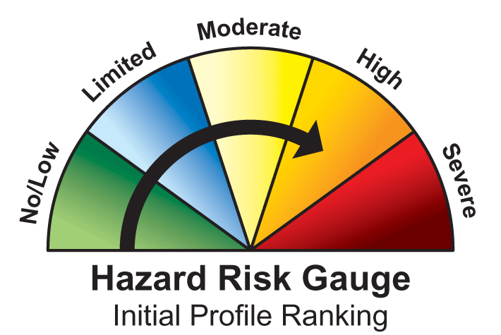
Potential Impact: | Small region
Onset: | No warning
Frequency: | Frequent event
Hazard Duration: | 4 days to 1 week
Cascade Effects: | Small potential
Recovery Time | 1 to 2 weeks

FLOOD HAZARD PROFILE
Background and Local Conditions
Floods result in greater property losses and damage and cause more casualties and fatalities each year than any other natural hazard. Several 100-year and 500-year floodplains are located within the Tompkins County along the shores of lakes, streams, creeks, and rivers. These areas are prone to relatively frequent floods and/or inundation, as the County receives high amounts of precipitation and subsequent run-off. When severe thunderstorms or storms associated with hurricanes or tropical storms occur, they often result in floods in Tompkins County. Flash floods also occur relatively frequently within the county. Flood hazard areas are defined as areas that would be inundated by a flood of a given magnitude. These areas are determined using statistical analyses of flood discharge data and hydraulic and topographic analyses. Tools such as FEMA’s Flood Insurance Rate Maps (FIRM) show street maps with flood hazard areas clearly shown. A 100-year flood has a 1-percent chance of being equaled or exceeded in any given year. This flood event is also referred to as the base flood. A flood that has a 0.2-percent chance of being equaled or exceeded in any one year is called a 500-year flood. See Sections 4.3 and 4.4 for data on homes and other buildings located within 100- and 500-year flood zones in the Tompkins County Multi-Jurisdictional Study area. Due primarily to the severity of the flood hazard in the region, a county-administered Flood Mitigation Program was established to help municipalities fund flood mitigation projects. The Town of Danby has used funds from this program for flood prevention projects during the last 10 years. All but one of the towns within Tompkins County (Enfield) participates in FEMA’s National Flood Insurance Program (NFIP), with current countywide coverage of more than $27 million. 203 claims have been made since 1978 by communities within Tompkins County, including those that are not part of the current study area (SEMO 2003).

Floods are problematic in numerous ways, including but not limited to water-related damage to the interior and exterior of buildings, especially homes, destruction of electrical and other expensive and difficult to replace equipment, loss of life, injury and proliferation of disease vectors, disruption of utilities, including water, sewer, electricity, and communications networks and facilities, loss of agricultural crops and livestock, placement of stress on emergency response and healthcare facilities and personnel, loss of productivity, and displacement of persons from homes and places of employment. Flood events require responses (such as pumping of basements and barricading roads) above and beyond the typical daily operations of emergency response organizations and fire departments (Tompkins County 2003f). Developments and resources in the bottoms of valleys and at the foot of steep slopes; mobile homes and mobile home parks in low-value, low-lying lands; and lakefront properties are particularly hard-hit by floods. Dam failure is also a concern to some Tompkins County residents due to the Virgil Creek Flood Control Dam (located in the Town of Dryden and impacting the Towns of Dryden and Ithaca and the City of Ithaca) and Jennings Pond Dam in the Town of Danby. Additionally, several historic milldams have been built on streams in the region, some of which are of questionable structural integrity due to their ages. Ice jams often cause flooding in Tompkins County during periods of spring thaw. Considerations involving ice jams are discussed further in the Hazard Profile for Severe Winter Storm (including Ice Storm).

Historic Frequency and Probability of Occurrence
Flooding is a major persistent hazard that affects Tompkins County, posing significant risk and resulting in repetitive loss and mitigation costs to the county and towns. The Tompkins County Partial Disaster Event History 1896-1999 compiled by Michael Raffe of the American Red Cross, Tompkins County Chapter, cites flood events that have occurred since 1935 (American Red Cross 2003). According to the National Oceanic and Atmospheric Administration (NOAA)’s National Climate Data Center (NCDC) storm events database, 16 significant floods were reported for Tompkins County between February 1994 and September 2003, including one major flood event, 10 flash flood events, and four events of urban/small-stream flooding. Several of these flash floods were associated with ice jams. Similarly, the Town of Dryden’s Hazard Mitigation Plan states that six significant flood events occurred in Dryden from July 1992 through June 1999. With respect to the probability of future flooding hazard events, the HAZNY report resulted in a frequency description term of a “frequent event” for flooding. The ground rules for the program quantify this descriptor as an event that occurs more than once a year. Based on historical information found on the NOAA website and data provided by FEMA on Presidential Declared Disasters, it is estimated that Tompkins County will continue to experience significant flooding each year (both in terms of frequency and impact), with possible major and flash floods that could result in a Presidential Disaster Declaration.
Severity
According to a recent NWS study, flooding (including flash flooding) is the most costly hazard facing Tompkins County. Tompkins County residents are particularly vulnerable to repetitive flooding because the historic population centers are clustered in valleys and along the shores of local creeks. Furthermore, Tompkins County is home to more than 1,300 manufactured homes. Residents of these types of homes are generally more vulnerable to flood impacts. Although injuries are unlikely, the impact on property and public infrastructure is moderate and can be highly destructive (Tompkins County 2003f).
Historic Losses and Impacts
Damages typically include structural damages (to private and public structures such as roads, bridges, homes, businesses, etc.) and losses of thousands of dollars per event for private residences, business owners, and municipal governments. Tompkins County has received numerous Presidential Disaster Declarations for flooding and other severe events (See Section 4.0 and Table 4-2-2). Flood damage occurs at a minimum of every other year, while extensive damage historically occurs every decade.

The flood of October 1981 caused about $10 million in damages in Tompkins County. The NCDC reports damages of more than $21.6 million from the 16 flood events reported in the county between February 1994 and September 2003. A countywide severe weather analysis for the period between 1993 and 2000 reported that flooding, while not the most frequent of the extreme weather events, is associated with the highest costs of any hazards in Tompkins County (NWS 2001). A flash flood in January 1996 caused nearly $20 million of property losses alone (NCDC 2001).

Since 2000, the Town of Caroline has implemented 8 flood mitigation projects with estimated costs of $464,073 (Schmidt 2004). Other towns also have considered or implemented mitigation efforts.
Designated Hazard Areas
The geography of Tompkins County includes steep slopes and large valleys; several municipalities are especially susceptible to chronic flooding events, including the Village of Groton, Town of Dryden, Village of Freeville (in the Town of Dryden), City of Ithaca, and the Town of Caroline and its hamlets that are near Six Mile Creek. In addition, lake flooding resulting from rain events can continue for several days to 2 weeks.

Figure 4-2-1 shows the areas within the Tompkins County Multi-Jurisdictional Study Area within the designated 100-year and 500-year flood zones.

Figure 4-2-1. 100- and 500-Year Flood Zones within the Tompkins County Multi-Jurisdictional Study Area

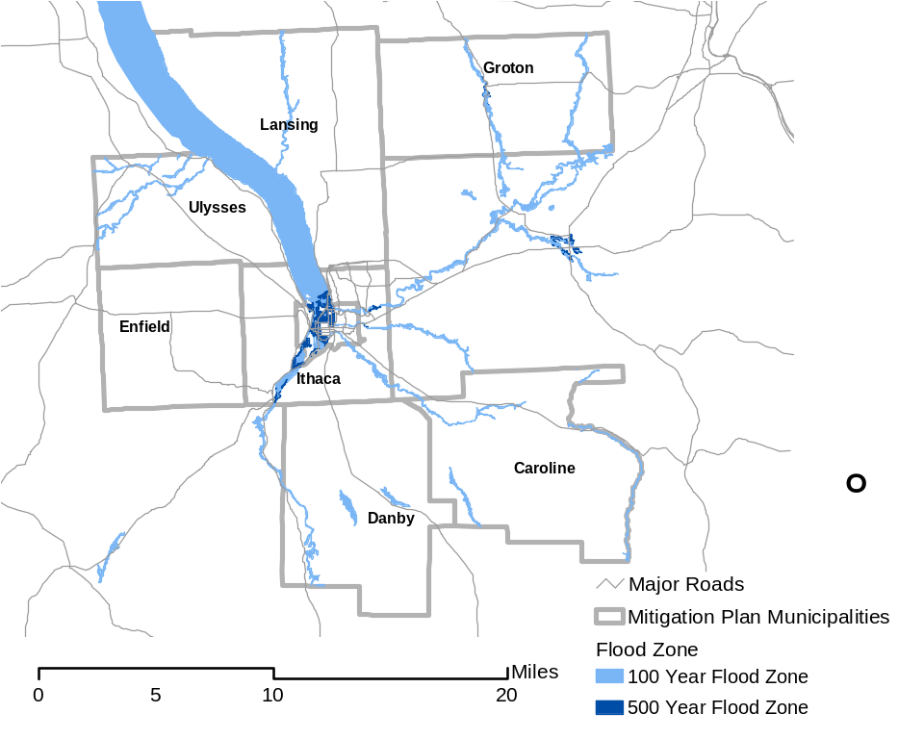
Source: HAZUS-MH (FEMA, 2004)

Table 4-2-2. Presidential Disaster Declarations
Type of Event | Date | Declaration Number | Cost of Losses (approx.)
Snow | March 1993 | DR 3107 | $113,939
Flooding | January 1996 | DR 1095 | $251,898
Flooding | November 1998 | DR 1148 | $225,152
Flooding | June through July 1998 | DR 1233 | $56,591
Severe storms and flooding | May through August 2000 | DR 1335 | $61,521
Severe storm | Summer 2002 | DR 1391 | $5,660
Total Cost |  |  | $714,761
Notes: Recorded losses indicate the dollar value of loss made available through public records reviewed for this risk assessment. Source: FEMA website (http://www.fema.gov/library/drcys.shtm)
4.2.1.2 Severe Winter Storm (Including Ice Storm)

HAZNY Summary of Risk Factors |  | Profile Ranking
Potential Impact: | Large region
Onset: | 1 day warning
Frequency: | Regular event
Hazard Duration: | 1 day
Cascade Effects: | Highly likely, including utility failure and transportation accidents
Recovery Time | 3 days to 1 week

SEVERE WINTER STORM HAZARD PROFILE
Background and Local Conditions
Heavy snowfall, coupled with low temperatures, often results in increases in traffic accidents, disruptions in transportation, commerce, government, and education, utility outages due to falling trees, branches, and other objects, personal injuries associated with slippery surfaces and freezing temperatures, and numerous other problems. Fortunately, Tompkins County is relatively well prepared for severe winter storms, having sophisticated response, early warning, and snow removal systems in place. The climate of Upstate New York, with its northern latitude and high precipitation rate, is conducive to the regular occurrence of severe winter weather, including ice storms. As such, severe winter storms present a significant hazard to life and property in Tompkins County. Severe winter storms can produce freezing rain, ice, snow, dangerously cold conditions, and freezing wind. The steep topography of Tompkins County adds to the hazard associated with snow and ice-related events. Of particular concern in Tompkins County and the municipalities is the increased likelihood of cascade effects from snow and ice, including utility failures, increased frequency and magnitude of transportation accidents, increased risk of injuries and death due to falls, hypothermia, and reduced access to emergency services (see also the profile for Utility Failure). As many homes in Tompkins County are served by well water with electric pumps and heated by electricity, utility failure associated with winter storms can result in people being without heat and water for prolonged periods of time. Severe winter storms, including ice storms, can cause numerous impacts to the social, political, and public safety infrastructure, as well, causing lost productivity and work time, school cancellations, transportation delays, increased road maintenance, and higher demands on community services. The elderly, infirm, homeless, impoverished, and other vulnerable populations are at increased risk of adverse impacts associated with severe winter storms and ice storms. Ice covers surfaces and results in significant damage to trees, building and infrastructure inventory, such as power lines, bridges, and substations. The freeze/thaw cycle, salts, sand, and heavy use of plows and trucks that often accompanies snow and ice storms results in formation of potholes, damaged roads and bridges, and increased maintenance costs to the affected communities. Tompkins County also experiences chronic ice jams that occur on the County’s abundant streams and often result in flooding. Although they typically occur during spring thaws, they are still related to winter storm conditions. These ice jams are particularly damaging to public infrastructure, such as bridges (Tompkins County 2003f). Damages and losses associated with severe winter storms are similar to those for ice storms. Most areas of Tompkins County experience the effects of winter storms frequently.

Historic Frequency and Probability of Occurrence
Several severe winter storms occur each year in Tompkins County and the participating municipalities. Numerous snowstorms in 1958 and the early 1960’s are documented in the Tompkins County Partial Disaster Event History 1896-1999 compiled by Michael Raffe of the Tompkins County Chapter of the American Red Cross. The blizzard of 1993 also affected the Tompkins County area (City of Ithaca 2003). The NOAA NCDC Storm Event database lists 29 heavy snow events during the period from November 1993 to February 2003 (see Figure 4-2-2). An ice storm in January 2003 left thousands of Tompkins County residents without power for several days. Figure 4-2-3 shows the number of ice storms that have affected the county by year since 1993.

Several recent severe winter storm events are described in the HAZNY Analysis of Tompkins County and the municipalities. Blizzards that hit the region in 1993 and 2003 resulted in closed roads and thousands of residents being without power for several days, requiring residents to use emergency shelters.

With respect to the probability of future severe winter storm hazard events, the HAZNY report resulted in a frequency description term of a “regular event” for severe winter storm. The ground rules for the program quantify this descriptor as an event that occurs between once a year and once every seven years (inclusive). Based on historical information found on the NOAA website it is estimated that Tompkins County will continue to experience two heavy snow events annually (Figure 4-2-2), with the secondary effects causing possible utility failure and transportation accidents. Additionally based on NOAA data, at least one ice storm has occurred annually between 1999 and 2003 with the exception of 2002 (Figure 4-2-3).
Severity
The intensity of the impact from severe weather could be minor to total damage in a localized area or regional damage affecting property and the economy, such as a hard frost occurring early in the growing season, killing off the season’s crop yield.

Historic Losses and Impacts
A countywide severe weather analysis for the period from 1993 to 2000 reported that winter storms, including heavy snow and ice, accounted for the most deaths and injuries of all severe weather events in Tompkins County (NWS 2001). In January and February 2003, Tompkins County experienced severe winter conditions including debilitating ice and snow. The County formally closed roads and thousands of residents were without power for several days, requiring residents to use emergency shelters. The NOAA NCDC Storm Event database identified property losses from the January and February 2003 heavy snow events at $6 million and $2.7 million, respectively.

The blizzard of 1993 presented similar conditions as those noted for the storm of January 2003. Other more specific events within the towns include:
- Town of Groton: closing of the town during a blizzard in 1993
- Town of Caroline: in January 2003, the town received 18 inches of snow after an ice storm, which caused downed trees, closure of roads, and loss of power to the entire town, portions of which did not receive power for 5 days
- Town of Ithaca: 15-24 inches of snow and ice for several days in January 2003 closed roads, interrupted utilities, and damaged buildings and trees; heavy snow and wind in March 1993 closed roads, interrupted utilities, and required extensive cleanup
- Town of Danby: Road closings in March 1993 due to a severe blizzard and power outages and tree damage from a severe storm in January 2003; during the latter storm, 1,700 households in the town had no power for 5 days. At that time, residents of Tompkins County and adjacent counties used the West Danby Fire Station as an American Red Cross shelter.

Damages from ice storms can range from briefly hazardous road conditions to near total loss of aboveground utility systems in the area and loss of energy transmission capability from the production site to the Ithaca grid, causing loss of life, severe property damage, and economic loss. Impacts from ice storms range from minor fender bender accidents with no personal injury to wide area catastrophic damage, involving loss of life, property damage, and severe economic hardship for the community (City of Ithaca 2003). An ice storm in January 2003 left thousands of Tompkins County residents without power for several days. The NOAA NCDC Storm Event database identified $1.1 million in property damage due to an ice storm in January 2003, and $200,000 of property damage resulting from an ice storm in January 1999.

According to Mr. Bud Shattuck, the Deputy Town Supervisor for the Town of Lansing, a traffic accident caused by a winter storm resulted in two state highways being blocked for 4 hours, and requiring truck traffic to be re-routed through the streets of Lansing. The truck traffic on the city streets, coupled with salt and sand applied to the roads reported caused nearly $250,000 in damage to the town’s streets, as well as delays in police and ambulance service.

Designated Hazard Areas
Essentially, all of Tompkins County is susceptible to winter storms. However, areas at particular risk include: certain areas with elderly, impoverished, or otherwise vulnerable populations; areas that are remote from community services and transportation corridors; antiquated or poorly constructed facilities (e.g., mobile homes); structures susceptible to power or telecommunications failure; and steep or hilly areas adjacent to water bodies, or served water from electric pumped-powered wells. Demographics, population density, transportation and considerations regarding construction, well usage, and topography in the region are presented throughout this plan.

Figure 4-2-2. Number of Heavy Snow Events in Tompkins County (1993– 2003)
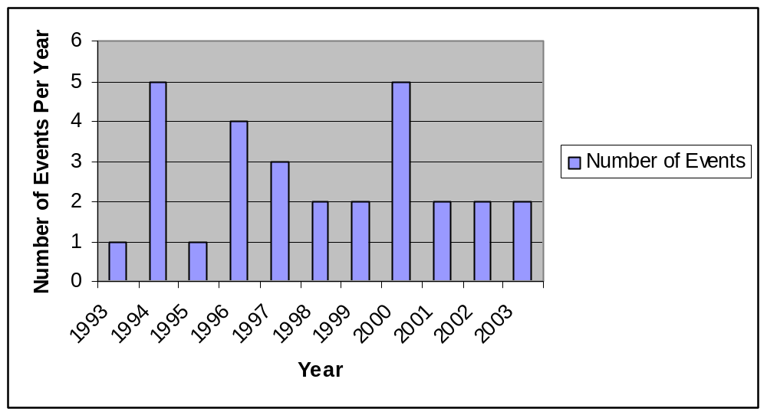
Source: NOAA NCDC Storm Event Database for Heavy Snow, 2003

Figure 4-2-3. Ice Storm Events in Tompkins County (1994-2003)
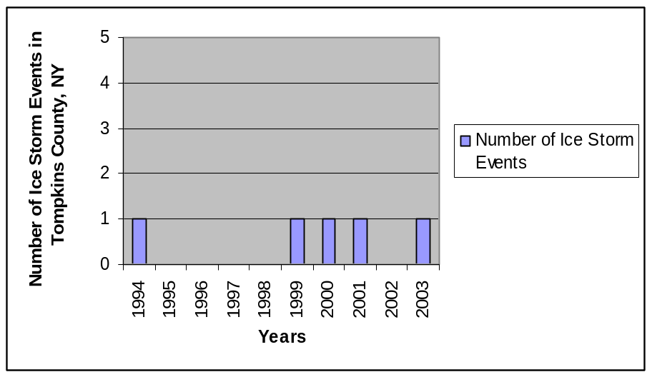
Source: NOAA NCDC Storm Event Database for Ice Storms, 2003
4.2.1.3 Severe Storm (Including Hurricane)

HAZNY Summary of Risk Factors |  | Profile Ranking 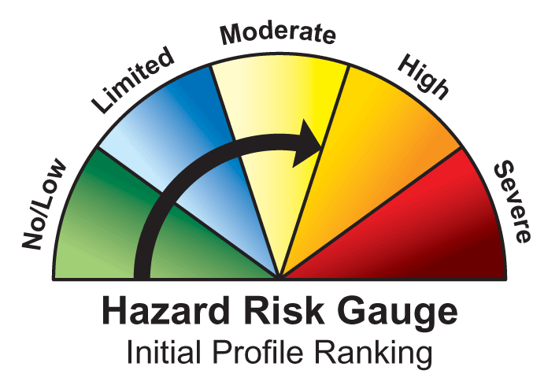
Potential Impact: | Large region
Onset: | Several Days Warming
Frequency: | Regular Event
Hazard Duration: | Less than 1 day
Cascade Effects: | Some potential
Recovery Time | 1 to 2 days

SEVERE STORM HAZARD PROFILE
Background and Local Conditions
The severe storm hazard includes hailstorm, severe windstorm, and severe thunderstorm. Tornadoes also are included, as they do not fit into another category(s). Severe storms in Tompkins County tend to damage building roofs and windows, vehicles, fences, signs, utility lines, and trees. Serious injuries or fatalities do not typically occur. The hurricane hazard is included in this category for the Tompkins County plan because hurricanes are rarely seen in Tompkins County, but the effects from hurricanes that impact adjacent areas on the U.S. East Coast tend to be similar to severe winds and thunderstorms. Severe windstorms can result in power outages, disruptions to transportation corridors and equipment, restricted workplace access, significant property damage, injuries, loss of life, and the need to shelter and care for individuals impacted by the events. Most of Tompkins County experiences windstorms frequently, and large-scale events tend to affect the entire county. The magnitude and frequency (up to three events per year) of wind events in the Towns of Ulysses and Lansing are greater than in other areas. The Town of Caroline also reports frequent exposure to winds of significant force (Tompkins County 2003e).

Full force hurricanes are not likely to occur in Tompkins County due to latitude and distance of the County from the Atlantic Ocean. Of greater impact in Tompkins County is the secondary flooding associated with hurricanes that hit areas closer to the coast. (Flooding is of particular concern in the County for reasons stated in the hazard profile for flood.) Tompkins County experienced flooding in association with Hurricanes Hazel and Floyd (1999) and tropical storm Agnes, particularly in the areas of Trumansburg (in the Town of Ulysses), Dryden, Groton, Freeville (in the Town of Dryden), and City of Ithaca (Tompkins County HAZNY 2003).

Historic Frequency and Probability of Occurrence
Windstorms and thunderstorms occur relatively frequently in Tompkins County; however, only a small fraction of all storms are considered severe. NCDC lists 104 thunderstorm and high wind events for the period between 1960 and 2003. Though wind speeds associated with previous storm events did not exceed 50 knots, a thunderstorm and wind event in Groton in 2003 featured winds of up to 70 knots. According to an American Red Cross Hazard Awareness and Assessment study covering an 8-year period from 1992 to 1999, 2 of the 163 severe weather events that occurred in Tompkins County during that period were windstorms. A county-wide severe weather analysis for the period 1993-2000 reported that close to 10 extreme weather events occur in the county per year, and that thunderstorm and high wind events are the most frequent of the extreme weather events in Tompkins County (NWS, 2001). Periods of extreme cold (temperatures below 0 degrees Fahrenheit) are experienced at least once per year (City of Ithaca 2003), though temperatures greater than 100 degrees occur rarely if ever. NCDC also lists five tornados and 14 hail events during the period 1960-2003 (see Figure 4-2-4).

According to the NCDC, no hurricanes were reported for Tompkins County since 1950. However, the county has felt the peripheral landward effects, including high winds, heavy rains, and flooding associated with several hurricanes and tropical storms in recent history. Most recently, high winds associated with Hurricane Isabel in October 2003 resulted in downed trees and utility disruptions. Tompkins County experienced near hurricane-force winds associated with a hurricane in 1935 (in which an estimated eight to 10 people died), Hurricane Hazel (October 1954), and extreme wind gusts again in the 1970s. (For one of these historical storms, Cornell University’s Barton Hall is known to have served as a shelter for approximately 800 people.) More recently, although not technically of hurricane force, local winds associated with Hurricane Isabel reached 40 to 50 miles per hour (Tompkins County 2003e). Figure 4-2-5 identifies historic hurricane tracks within Tompkins County.

With respect to the probability of future severe storm hazard events, the HAZNY report resulted in a frequency description term of a “regular event” for severe storm. The ground rules for the program quantify this descriptor as an event that occurs between once a year and once every 7 years (inclusive). Based on historical information found on the NOAA websites 15 severe storm event days have occurred from 1999 to 2003, 4 tornados (2 FO, 2 F1) have occurred from 1961-2003. Data provided by FEMA on Presidential Declared Disasters identifies 2 Presidential Declared Disasters since 2000 (Table 4-2-3). It is estimated that Tompkins County will continue to experience severe storms annually that may induce secondary hazards such as utility failure and transportation accidents.
Severity
The severe storm hazard is of moderate severity due to the fact that it affects a large region, allows little or no warning time, and occurs regularly. Damages tend to be relatively minor (such as damaged building roofs), but are widespread. The hazard duration is less than 1 day, with a recovery time of 1-2 days (Tompkins County 2003e). Severe storm and hurricane hazards tend to disproportionately affect elderly and infirm persons because they are less able to prepare their homes for storms and are often immobile and unable to evacuate when necessary.

The damage from hurricane-force winds would be severe (due to widespread damages to buildings and utilities from downed trees especially) and of the greatest magnitude in the Towns of Lansing and Ulysses because of topography and geography. A consequence of the severe storm and hurricane event is flooding (Tompkins County 2003e). An additional cascade effect of severe storm events is lost power due to downed power lines.

Historic Losses and Impacts
A countywide severe weather analysis for the period 1993-2000 reported that extreme weather events cost an average of $2.9 million annually in Tompkins County (NWS 2001). In 1989, portions of Tompkins County (including the Towns of Ulysses and Lansing) experienced extreme winds that downed many trees and tore off the side of a brick apartment building on Graham Road in the Town of Lansing. In July 2003, Tompkins County experienced high-speed winds that resulted in the loss of power to 6,000 residents. The Town of Groton, and particularly the hamlet of McLean, was particularly affected by this event and the magnitude of damage in McLean was substantial.

The towns in Tompkins County report the following recent events:
- Town of Ulysses: extreme winds during the summer of 1987 that damaged farm structures, houses, and trees
- Town of Groton: extreme wind shear in 1986 that resulted in loss of power and a significant number of downed trees
- Town of Caroline: in September 1998, the southern portion of town experienced winds that caused extensive damage including lost trees, power outages, and damages to the roofs of private residences (Tompkins County 2003e)

The Syracuse Labor Day windstorm of 1999 caused widespread loss of electrical service for approximately 1 week and significant damage to trees and private property. Excessive winds in January 2000 interrupted utility service, closed roads, and damaged trees and buildings. Hailstorms have regularly caused major crop and property damage in the Ithaca area (City of Ithaca 2003).

The NCDC indicated over $750,000 in property losses resulting from tornados in Tompkins County during the period 1950-2003. A high wind event in January 2000 caused about $1.1 million in damages across a multi-county area. High winds associated with Hurricane Isabel in September 2003 caused an estimated $850,000 in damages and lost power for thousands over a multi-county area, including Tompkins County. Thunderstorm wind events frequently are associated with $10,000-$20,000 in property damages each. Thunderstorm wind events in Groton in June 2002 and August 2003 resulted in $150,000 and $400,000 in property damage, respectively (NOAA NCDC 2004). Table 4-2-3 identifies storms that resulted in Presidential Disaster Declarations.
Designated Hazard Areas
Severe storms and associated wind may occur throughout the mitigation plan area; however the impacts to property may be greatest to manufactured homes, vehicles, and other nonpermanent structures. Figure 4-2-6 indicates those areas with manufactured homes (mobile homes and mobile home parks). Figure 4-2-7 indicates that Tompkins County falls in Wind Zone III according to FEMA and could experience winds up to 200 mph.

The entire county can be considered a designated hurricane hazard area. Vulnerable structures include older building districts (not able to handle high winds), mobile home communities, power grid hubs (loss or damage of which could affect large numbers of people), and areas near rivers or lakes that could be affected by flooding.

Figure 4-2-4. Tompkins County Severe Storm Events (1960-present)
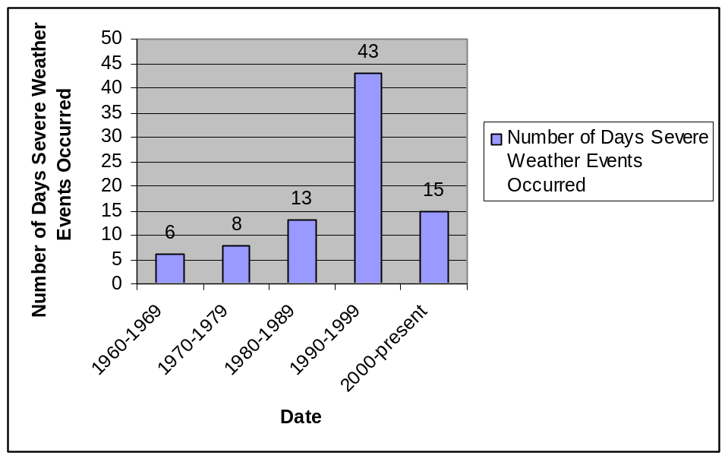
Source: NOAA NCDC Storm Event Database for Severe Storms, 2003

Note: NOAA tracks the storm events by type of storm event and location. Because the data set above includes all of Tompkins County, some of the events occurred outside of the study area and in some instances more than one event is recorded for some days. For this figure, all days storm events occurred are tabulated, so repetitive dates are not included. It is considered likely that significantly more events were reported since 1990 due in large part to improved meteorological equipment and reporting, as well as revised definitions of severity for the various types of storm.

Table 4-2-3. Presidential Disaster Declarations
Type of Event | Date | Declaration Number | Cost of Losses (approx.)
Snow | March 1993 | DR 3107 | $113,939
Flooding | January 1996 | DR 1095 | $251,898
Flooding | November 1998 | DR 1148 | $225,152
Flooding | June through July 1998 | DR 1233 | $56,591
Severe storms and flooding | May through August 2000 | DR 1335 | $61,521
Severe storm | Summer 2002 | DR 1391 | $5,660
Total Cost |  |  | $714,761
Notes: Recorded losses indicate the dollar value of loss made available through public records reviewed for this risk assessment. Source: FEMA website (http://www.fema.gov/library/drcys.shtm)

Figure 4-2-5. Historical North Atlantic Tropical Cyclone Tracks (1851-2002)

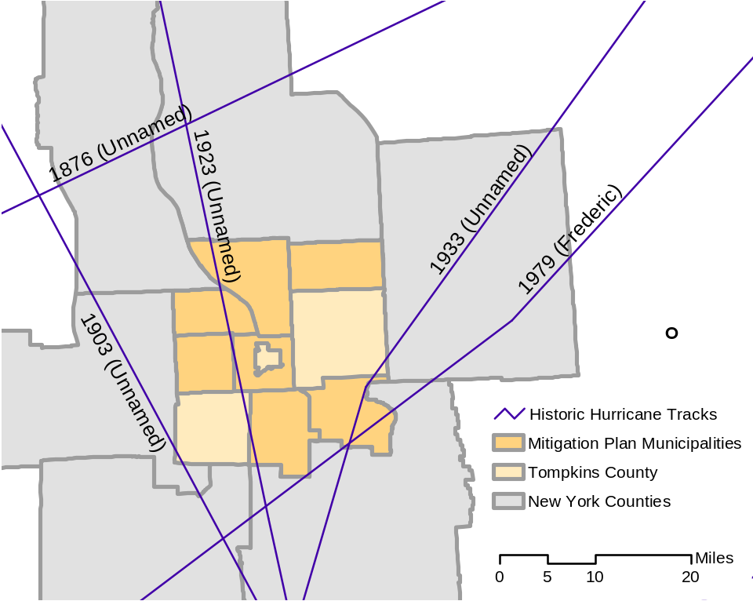

Source: National Oceanic and Atmospheric Administration (NOAA), Tropical Prediction
Center/National Hurricane Center, 2003

Figure 4-2-6. Manufactured Homes in Tompkins County Multi-Jurisdictional Study Area
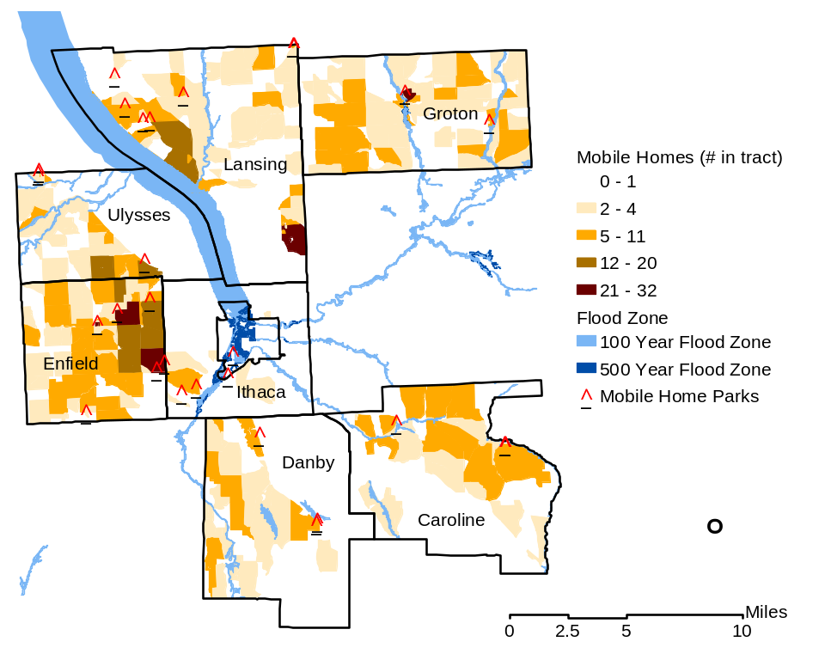
Source: HAZUS-MH (FEMA, 2004); John Anderson (TCDOH, 2004)
Note: The mobile home park indicated as farthest south in Danby actually includes two parks, but at this scale they appear as one park. This overlap also occurs for the northernmost park in Lansing and eastern most park in Caroline. The parks in Ithaca are indicated as “College View Trailer Park”, “College View North Trailer Park”, and “Shady Farm Trailer Park”.

Figure 4-2-7. Wind Zones in the United States

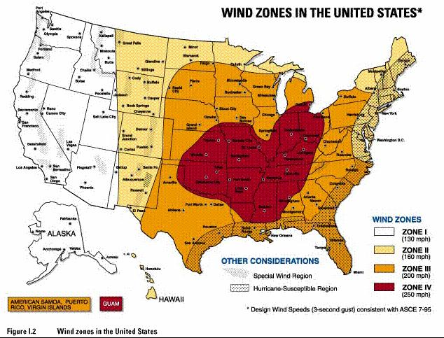
Source: FEMA

4.2.1.4 Epidemic (Agricultural)

HAZNY Summary of Risk Factors |  | Profile Ranking
Potential Impact: | Large region
Onset: | No warning
Frequency: | Frequent event (animals)
Hazard Duration: | More than 1 week
Cascade Effects: | Highly unlikely
Recovery Time | More than 2 weeks

Epidemic (AGRICULTURAL) HAZARD PROFILE
Background and Local Conditions
Much of Tompkins County’s economy relies on agricultural and farming practices and, as a result, incidences of epidemics that threaten animals are a significant concern in Tompkins County and are capable of having a large impact on the local economy and population.

According to agricultural data for Tompkins County from the U.S. Department of Agriculture (USDA), 18,900 head of cattle were present in Tompkins County in 2003. In 2000, the county was home to 1,000 hogs and 2,200 sheep. According to the USDA, in 2001, Tompkins County farmers harvested 13,100 acres planted in corn (silage and grain), about 20,000 acres planted in hay, 2,400 acres planted in oats, 1,600 acres planted in soybeans, and 2,600 acres in wheat and winter wheat.

Beginning in the 1970’s, poultry disease became an important concern for Babcock Breeders, who implemented self-quarantine procedures that are still used to protect breeding stock. Hog farming and livestock operations have similar concerns, and have implemented mitigation measures including limiting access to these areas by people.

Historic Frequency and Probability of Occurrence
Global trends indicate there are predictable cycles of pandemic epidemics. Medical experts suggest the next cycle is approaching and recommend that local facilities begin preparing (Tompkins County 2003e).

Common livestock diseases that may affect Tompkins County include Johnes Disease and Foot and Mouth Disease (Tompkins County Soil and Water Conservation District 2003).

With respect to the probability of future agricultural epidemic hazard events, the HAZNY report resulted in a frequency description term of a “frequent event” for animals. The ground rules for the program quantify this descriptor as an event that occurs more than once a year. Currently, based on the best available data there is no historical record of agricultural epidemics in Tompkins County; however, with the recent outbreak of Mad Cow disease in the United States, concern over potential impacts to dairy and beef cattle in Tompkins County has heightened. Large events such as the Syracuse annual livestock auction could increase the frequency of occurrence. In the past 20 years, Tompkins County concern about the potential occurrence of disease in hogs and mad cow disease has increased (Tompkins County 2003e) and that heightened concern is expected to continue.
Severity
This hazard is ranked as severe for farm animals since agriculture is a predominant industry in Tompkins County. This hazard would impact a large region and has no warning time. The event is estimated to last more than 1 week with a recovery time of greater than 2 weeks (Tompkins County 2003e). The overall severity ranking is high.
Historic Losses and Impacts
In Tompkins County, there is no history of major epidemics affecting crops or livestock; however Tompkins County assumes the impact of an epidemic upon the study area would likely result in serious injury or death but not in large numbers, severe damage to private property (agricultural animals), and little to no structural damage to public facilities (Tompkins County 2003e).

Designated Hazard Areas
All agricultural animals are theoretically susceptible to a disease outbreak that affects the respective species. Specific agricultural epidemic hazard areas within the Tompkins County study area include the Town of Groton, which has a higher number of dairy farms than any other town in Tompkins County, and the Town of Enfield, which relies on agriculture as its dominant industry. Figure 4-2-8 identifies the agricultural areas within the mitigation plan area that could be most affected by an outbreak. A large regional livestock auction is held each year in Syracuse and is attended by numerous cattle and owners from Tompkins County. An outbreak at this auction could result in high losses under certain conditions (e.g., highly infectious vector).

Figure 4-2-8. Map of Agricultural Epidemic Exposure Areas in Tompkins County Multi-Jurisdictional Study Area
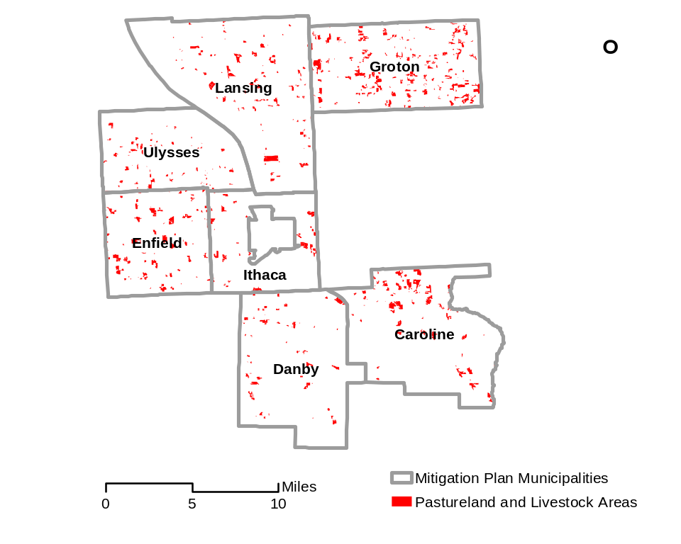
Source: HAZUS-MH (FEMA 2004)

4.2.1.5 Epidemic (Human)

HAZNY Summary of Risk Factors |  | Profile Ranking 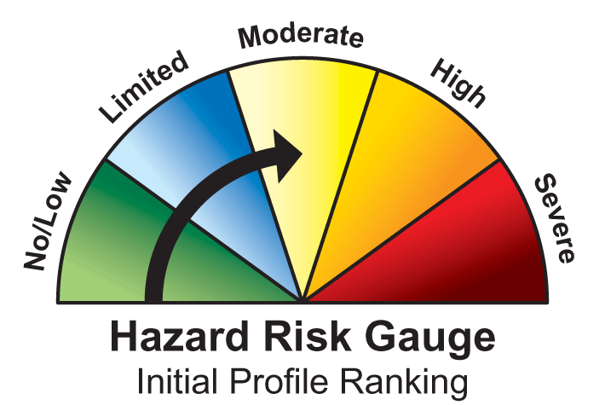
Potential Impact: | Large region
Onset: | No warning
Frequency: | Rare
Hazard Duration: | More than 1 week
Cascade Effects: | Highly unlikely
Recovery Time | More than 2 weeks

Epidemic (HUMAN) HAZARD PROFILE
Background and Local Conditions
The epidemic hazard for Tompkins County is separated into risk of disease outbreak in humans and agricultural resources, including crops and livestock. This section discusses the epidemic hazard related to disease outbreak in human populations. The vulnerability of Tompkins County to the impacts of global epidemics is particularly high because of Ithaca College and Cornell University. Both institutions have a significant number of international students and Cornell University is a major international research facility. The recent concern over the Severe Acute Respiratory Syndrome (SARS) was felt strongly in Tompkins County, as preparations were made by the Tompkins County Health Department to prevent the potential spread of the disease by students and others attending the Cornell University graduation ceremonies from China, the presumed origin of the disease. According to Ms. Alice Cole, the Public Health Director of the County Health Department, the State Health Department was the primary source of precautionary measures against the SARS outbreak (Cole 2004a). Tompkins County has implemented a Health Emergency Operations Plan that outlines measures to be taken in the event of an outbreak, including information on response protocols for hundreds of diseases. A similar state plan outlines measures to be undertaken by county authorities in the event of a bioterrorist attack.
Historic Frequency and Probability of Occurrence
Global trends indicate there are predictable cycles of pandemic epidemics. Medical experts suggest the next cycle is approaching and recommend that local facilities begin preparing (Tompkins County 2003e).

With respect to the probability of future human epidemic events, the HAZNY report resulted in a frequency description term of “rare” for a human epidemic event. The ground rules for the program quantify this descriptor as an event that occurs less than once every 50 years. According to Ms. Alice Cole, the Public Health Director of the Tompkins County Health Department (Cole 2004a), no major disease outbreaks have occurred in Tompkins County in recent memory and are not predicted, although there is a potential for it, given the presence of a major international research institution (Cornell University) in Tompkins County.
Severity
The human epidemic hazard is ranked moderately low to moderate in Tompkins County, due to the preventive measures in place and the lack of historical outbreaks in the county. However, an outbreak could impact a large region and, with no warning time, could result in casualties or fatalities before being brought under control. Epidemic events are estimated to last more than 1 week with a recovery time of greater than 2 weeks (Tompkins County 2003e).
Historic Losses and Impacts
Tompkins County does not have history of human epidemic events. Tompkins County assumes the impact of an epidemic upon the study area would likely result in serious injury or death but not in large numbers, and potentially high economic impacts associated with emergency response, hospital care, lost productivity, and stress on local public safety infrastructure. Little or no structural damage would be expected to property or structures (Tompkins County 2003e).
Designated Hazard Areas
The entire population of the county and municipalities is feasibly susceptible to the impacts of a disease outbreak.

4.2.1.6 Fire (Urban and Wild)

HAZNY Summary of Risk Factors |  | 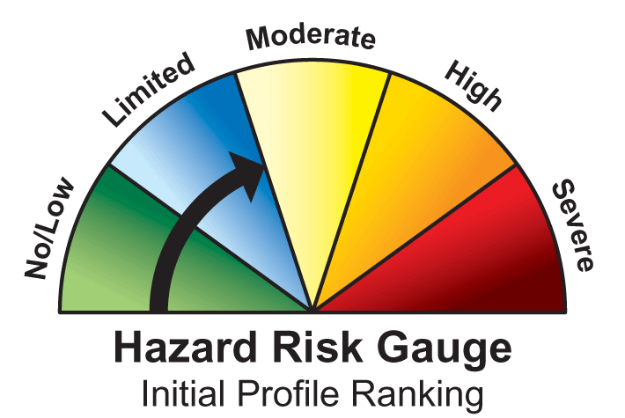  Profile Ranking
Potential Impact: | Small region
Onset: | No warning
Frequency: | Regular event
Hazard Duration: | Less than 1 day
Cascade Effects: | Some potential
Recovery Time | 1 to 2 days

FIRE HAZARD PROFILE
Background and Local Conditions
Urban and wild land fire, while generally local in impact in Tompkins County and the municipalities, is capable of rapidly causing complete destruction of property, assets, natural resources, and human life and health. The costs associated with fire prevention, fighting, and recovery can be very high. NOAA’s NCDC maintains records of wild and forest fires in Tompkins County since 1950. According to the NCDC website, no significant wildfires were reported for Tompkins during this period. The climate of Tompkins County is not conducive to large-scale drought and dry climate vegetation that are primary causes of the massive and highly destructive wildfires that occur periodically in the Western United States.

Significant structural fires have occurred in the population centers of Dryden, Groton, and Newfield (Dryden and Newfield are not included in this plan’s study area). These and other fire-related events are considered to be hazardous because of their impacts on medical facilities and emergency medical responders and the need for food- and shelter-support services. The older housing stock in many areas in Tompkins County has not yet been updated with sprinklers and is vulnerable to fire. Many students of Ithaca College and Cornell University live in these houses; fire is a particular concern in these residences (Tompkins County 2003e).

Of particular concern in Tompkins County and the municipalities with respect to fire involve the ability of the local fire and emergency response personnel to respond to fires that occur in the smaller towns and rural areas where fire suppression equipment and water is not readily available. For example, a hose attached to a hydrant approximately 1.5 miles away from the fire supplied the water used for fire suppression at a site in Danby. Small brush fires occasionally occur in the study area.
Historic Frequency and Probability of Occurrence
According to the American Red Cross Hazard Awareness and Assessment, fires accounted for 89 percent of all hazard events in Tompkins County for the 8-year period 1992-1999 (145 of 163 disaster events), with 7 large fires affecting multiple families over an 8-year period. The Tompkins County Partial Disaster Event History 1896-1999, compiled by Michael Raffe of the Tompkins County Chapter of the American Red Cross, cites fire events throughout the range of years documented (1900, 1907, 1912, 1959, 1962, 1966, 1998 [two events], and 1996.) Thirteen brushfires around Tompkins County were reported in March 1999; however, damage was minimal. This suggests that the response capabilities are effective and the fire hazard is well-managed in Tompkins County and the municipalities.

With respect to the probability of future fire (urban and wild land) hazard events, the HAZNY report resulted in a frequency description term of a “regular event” for fire. The ground rules for the program quantify this descriptor as an event that occurs between once a year and once every 7 years. Based on the historical data provided above it can be estimated that the likelihood of urban and wild land fires occurring will be higher for urban fires than wild land fires. Additionally, based on the age of the housing stock in Tompkins County and the increase in fuel prices people are turning to alternate sources of heat and air conditioning, thus increasing the danger of fire. The trend in the number of fires is predicted to continue due to the above reasons and the inability of code enforcement inspectors to keep up with the housing stock inspections (Raffe 2004).

Severity
Impacts to human health and safety and property from major urban fires are often severe and direct. The intensity of fire impact can range from minor to significant. Fires have significant community-wide impacts, especially when lives and homes are claimed. A fire in a Cornell University laboratory facility could ruin years of research work, costing millions of dollars. A fire in a manufacturing facility can result in the closing and relocating of the business elsewhere (City of Ithaca 2003).
Historic Losses and Impacts
In July 1998 in the Town of Danby, a fire along Bald Hill Road destroyed a major business resulting in the loss of 10 jobs and several lumber mill buildings. In June 1999, a fire in Central Danby resulted in the loss of the only convenience store and gas station in town as well as five local jobs. Danby reported several smaller fires that damaged farm properties in 2002 (Tompkins County 2003e).
Designated Hazard Areas
Urban areas have the potential for greater damage to infrastructure, loss of life, and strain on existing healthcare facilities and emergency responders due to its higher structural and population densities. While the majority of urban areas and associated fire events in Tompkins County are located in the City of Ithaca (although not within the scope of this study), urban areas within the study area include the population centers in the Towns of Ithaca, Lansing, Groton and Ulysses (see Figure 4-2-9). Structural urban fires typically impact individual or closely clustered buildings. Building densities are addressed in Section 4.3 of this plan. Wide-reaching woodland fires, though uncommon in the region, would be more likely to strike heavily forested areas during dry periods. Forested areas are shown in figure 4-2-9.

Figure 4-2-9. Urban and Wild Land Fire Hazard Areas in Tompkins County Multi-Jurisdictional Study Area

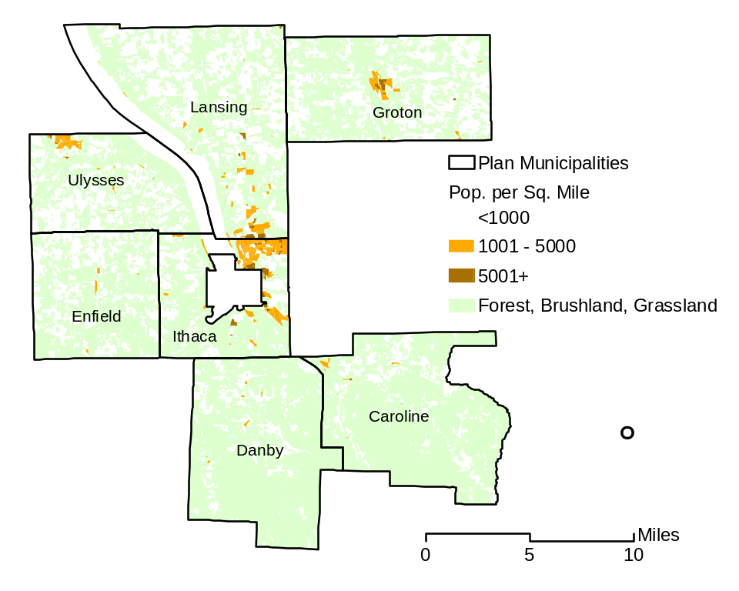
Source: HAZUS-MH (FEMA 2004)

4.2.2 Technological Hazards

This section presents profiles of the one natural hazard of concern selected for further profiling and evaluation.
4.2.2.1 Utility Failure

HAZNY Summary of Risk Factors |  | Profile Ranking
Potential Impact: | Large region
Onset: | No warning
Frequency: | Infrequent event
Hazard Duration: | Less than 1 day
Cascade Effects: | Some potential
Recovery Time | Less than 1 day to 1 week

UTILITY FAILURE HAZARD PROFILE
Background and Local Conditions
Utility failure in Tompkins County, especially electricity, is a significant concern, as many homes and businesses in the county and municipalities rely on electricity to heat and cool their homes and workspaces, power pumps for private drinking water wells, cook their food, treat and pump water supplies, heat their water, and refrigerate their perishable foods. Many utility lines in Tompkins County are overhead and subject to damage from vehicles, downed trees, ice, snow, rain, wind, and malfunction. Downed utility lines or damaged underground utilities can take days to repair. During periods of extreme winter or summer weather, power outages can literally be the difference between life and death, especially for the elderly, infirm, or otherwise vulnerable populations of Tompkins County. Utility failure as it relates to the facilities and population of Tompkins County is the loss of a life line service such as electricity or natural gas and its affect on the population or infrastructure, but also a release of hazardous materials or waste from local businesses that utilize or produce hazardous materials in their operations (such as Thermo or Emerson Power Transmission.) A natural gas pipeline runs through the southern portion of Tompkins County, and AES Cayuga and its railroad transport system are also areas of concern and potential hazard areas (Tompkins County 2003f). A May 2003 Pipeline Group Emergency Response Manual identifies that pipelines carrying diesel fuel, fuel oil, jet fuel, gasoline, kerosene, natural gas, and propane are operated by four companies in Tompkins County. Several natural gas pipelines cross Six Mile Creek, which is also a major drinking water source for the study area. While the possibility exists for natural gas pipelines to rupture and release product to the air or water, such events occur infrequently. A ruptured natural gas line would not necessarily impact the water supply, since the product is highly volatile and would partition to the atmosphere. However, natural gas is highly flammable and a release would cause an explosion hazard that must be handled delicately prior to attenuation of the product in the air. In addition, ruptured or otherwise blocked natural gas lines can result in increased maintenance and replacement costs and disturbance of supply to consumers, which, during winter months, can be hazardous. Several petroleum pipelines traverse the study area as well. Ruptured petroleum pipelines can be very costly not only to the utilities, but also to the affected natural and human environments, including possible adverse effects to water, soil, and wildlife, and associated high cleanup costs.

Of particular local concern is the fact that New York State Electric and Gas (NYSEG)’s principal maintenance and construction crews representing the study area have been relocated in recent years from Tompkins County to Binghamton; this move has resulted in delays in the restoration of power following outages and loss of familiarity to “problem areas” in the county by the maintenance crews. This situation was illustrated during an ice storm of January 2003 when out-of-town utility crews had difficulty orienting to the local configuration, resulting in delayed power restoration.

Communication across entities also impacts hazard results. In January 2003 storms, both the Highway Department and the NYSEG were working to address downed lines and downed trees, and were not communicating consistently. NYSEG and local agencies must work together to ensure that there are not communication/response problems in the future. The Highway Department suggested that NYSEG crews be dispatched from local highway departments, and/or otherwise team up with the Highway Department crews (Beeners 2004d).

Historic Frequency and Probability of Occurrence
With respect to the probability of future utility failure hazard events, the HAZNY report resulted in a frequency description term of an “infrequent event” for utility failure. The ground rules for the program quantify this descriptor as an event that occurs between once every 8 years and once every 50 years. Based on the best available historical data, local water treatment facilities have suffered 2-6 hour power outages that have caused failure of their facilities over the years. It is estimated that Tompkins County will continue to experience utility failures annually that may induce cascade effects, such as transportation accidents and water treatment facility failure. Tompkins County will continue to attempt to obtain historic utility failure data, including number, type, and duration of outages from utility companies, county and town public works representatives, and media sources.
Severity
The severity of impact can depend on the amount and material released from a certain facility and where the facility is located within Tompkins County. It will also depend on the numbers of people without power or natural gas (heat) and the duration of the loss. Therefore the range of severity is minimum impact to severe impact to people and infrastructure.
Historic Losses and Impacts
Historic data for this hazard is somewhat limited. Instances of utility failure in Tompkins County include:
- Town of Ulysses: occasional power outages typically lasting 1 day or less
- Town of Groton: 4-hour power outage in January 2003
- Regional: Summer 2003 (“the black out” in August 2003)

The Tompkins County Health Department reports that, prior to 1981, landslides disrupted the City of Ithaca’s water supply system, and both the Cities of Ithaca and Cornell’s wastewater treatment plants (WTPs) had been disrupted by power outages. A power outage in 2002 at the Bolton Point WTP prompted the installation of a back-up power supply.
Designated Hazard Areas
All facilities and resources in Tompkins County that require electricity, gas, telecommunications, and other utilities to provide light, heat, water, etc., including homes, businesses, government facilities, and critical facilities, are vulnerable to problems associated with utility failure. Figure 4-2-10 shows petroleum and natural gas pipelines located in Tompkins County and the municipalities.

Figure 4.2-10. Pipelines within the Study Area
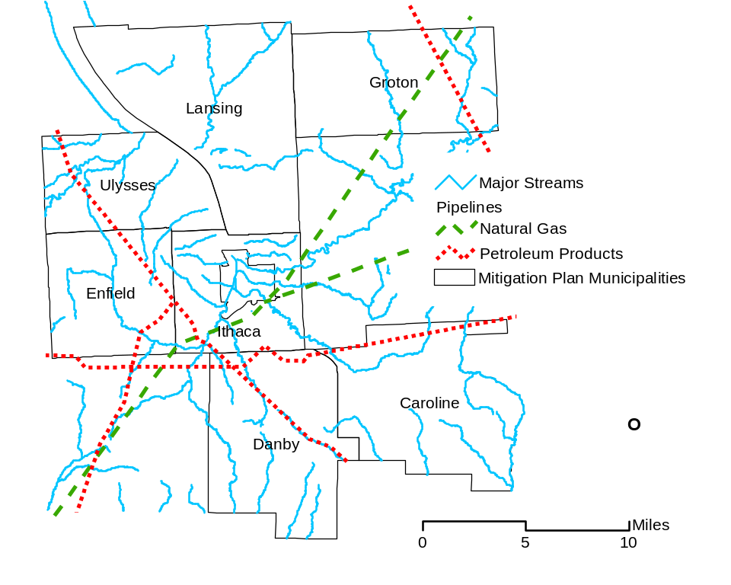
Source: (Pipeline Group, 2003)

4.2.3 Human-Caused Hazards

This section presents profiles of the four human-caused hazards of concern selected for further profiling and evaluation.

4.2.3.1 Transportation Accident (Including HazMat Release [In Transit])

HAZNY Summary of Risk Factors |  | Profile Ranking
Potential Impact: | Large region
Onset: | No warning
Frequency: | Infrequent event
Hazard Duration: | Less than 1 day
Cascade Effects: | Some potential
Recovery Time | 1 to 2 days

Transportation Accident HAZARD PROFILE
Background and Local Conditions
Significant losses and damages associated with major transportation system disruptions in the study region are associated with the following potential situations:

- Injuries, including fatalities, associated with accidents, especially in association with other hazards evaluated in this document (e.g., ice storms, severe winter storms, and flooding)
- Losses and damages to assets such as automobiles and infrastructure from direct impact during accidents
- Increased pressure on public safety infrastructure, such as police, fire, and rescue personnel, as well as community funds associated with emergency response
- Disruptions and potentially lengthy delays for motorists following the accidents, and increased traffic on alternative routes and detours
- Releases of hazardous materials, such as oil, gasoline, industrial chemicals, when tanker trucks, rail cars, or other transport vehicles are involved in accidents

Residents, commuters, and those traveling to and from Cornell University and Ithaca College heavily use commuter and long-distance bus services in Tompkins County. This travel is complicated by the lack of arterial access to major interstates in the region. Major transport routes to Tompkins County are typically two-lane roads with steep grades and curves and significant vehicular congestion (Tompkins County 2003e). Tompkins County also hosts a regional airport located in Lansing, serving private and leased (corporate) aircrafts and one commercial regional carrier. Several freight rail lines lie within and cross Tompkins County. Train derailments and other accidents involving trains can result in chemical spills, injuries and death, and high response and cleanup costs, as well as stress on the affected community’s services. When train derailments occur near water bodies, the human and natural environment, including possibly part of the county’s water supply, as well as habitat, are vulnerable to major financial and safety-related impacts. Of primary concern to Tompkins County are potential losses and damages associated with hazardous materials releases that occur during transportation in the study region. Such situations result in problems similar to the transportation accidents described above, as well as the following:

- Impacts to environmental media, including surface water, soil, groundwater, and air from hazardous material contamination, plus associated cleanup costs
- Losses and damages to assets such as vehicles and infrastructure from direct exposure to hazardous materials, associated fires, and hazardous mixtures generated during accidents
- Increased pressure on public safety infrastructure, such as hazardous materials response teams, police, fire, and rescue personnel, as well as community funds associated with emergency response

The steep topography of Tompkins County and the presence of several extreme turns on roadways have resulted in spills associated with the transportation of materials. Due to the lack of arterial access to major transportation routes, several State roads that traverse Tompkins County receive significant travel including State Route No’s. 79, 13, 96, 34, and 89. These roads are major transport routes for all types of materials, including hazardous materials (Tompkins County 2003e). Many of the transportation routes pass through rural communities and landscapes, and remediation of spills along these routes is often delayed and can be challenging because of delayed detection and/or limited accessibility (Tompkins County 2003f).

Historic Frequency and Probability of Occurrence
The on-line U.S. Coast Guard Emergency Response Center database indicates that several events involving hazardous materials releases have occurred in Tompkins County from mobile sources since 1990 spilling both to land and water. Most of the releases identified on the database involved fuels and other petroleum products. No patterns were observed in the locations of the hazardous materials releases. No cost or damage information was available for review. The probability of a hazardous material release is a function of the number of vehicles that transport hazardous materials in the county. An estimate of the number of trucks that pass through Tompkins County hauling hazardous waste and materials is difficult to determine due to under-reporting. However, according to the Tompkins County Freight Transportation Study (April 2002), 434 freight trucks entered or passed through Tompkins County during one 2-hour period (2:00 p.m. to 4:00 p.m. on a Friday). In addition, a rail system that primarily transports coal and salt runs through the Town of Danby and along the eastern shore of Cayuga Lake. According to data provided by the Division of Motor Vehicles between 1991 and 2001 there were 6 fatal accidents, 740 personal injury accidents, 1,024 accident injuries, 1,815 property damage accidents, and 2,561 total reportable accidents (NY DMV 2002).

With respect to the probability of future transportation accidents (including HazMat Release [In Transit]) hazard events, the HAZNY report resulted in a frequency description term of an “infrequent event” for transportation accident. The ground rules for the program quantify this descriptor as an event that occurs between once every 8 years and once every 50 years. This type of hazard is impossible to accurately predict; however, areas prone to accidents can be located and quantified through analysis of historical records and plotted on a county base map. Certain characteristics that together cause accidents or increase vulnerability to potential accidents can be outlined and areas that may be prone to accidents are identifiable (for example, see Figure 4-2-12 which identifies transportation routes that intersect water bodies in Tompkins County). Based on historical information it is estimated that Tompkins County will continue to experience transportation accidents in the same historic magnitude, some of which could result in the release of chemicals that may induce cascade effects such as water supply contamination and additional transportation accidents as traffic is diverted.
Severity
The risks associated with the transportation accident hazard are considered high based on the fact that such events can occur at any time and in any location. Impacts can range from a minor “fender-bender” to a multi-vehicle or fatal accident to a large-scale spill of a hazardous chemical. The duration, time, and location of an accident are critical in the interpretation of the associated risks for a non-hazardous material-related accident.

The severity of hazardous material releases is directly related to the type, volume, composition, characteristics, and chemical state of the material(s) involved. Releases of highly hazardous, infectious, radioactive, flammable, corrosive, or toxic industrial chemicals, fuels, or wastes, can result in large, regional impacts if toxic gases or vapors are formed, if surface water is impacted, or if they occur in populated areas. The emergency response capabilities of Tompkins County and the municipalities are excellent; however, location and characteristics of a spill can determine the amount of time necessary to stabilize a release and minimize the amount of damage that could result to people, assets, and resources of the community. Spills in rural areas may cause a delay in notification and the initiation of remedial action allowing the material to spread and resulting in greater detrimental effects to people or the environment. A spill of material into the eastern shore of Cayuga Lake has resulted in significant water quality and aquatic ecosystem impacts in that area (Tompkins County 2003e).

Historic Losses and Impacts
Traffic accidents occur relatively frequently in Tompkins County and the municipalities, as in other localities. Annotated information regarding the number and damages associated with specific accidents was not identified. In 1991, a multiple vehicle accident involving a Greyhound bus over-burdened emergency response services, as did another bus accident along Route 13 in the Town of Ithaca (near K-Mart and Ithaca Shopping Plaza) in 2001 (Tompkins County 2003e). No losses have been identified related to air travel or the local airport in Lansing.

Events that have recently occurred in the study area include:
- Town of Ulysses: Overturned fuel truck along Route 96 in 1988
- Town of Danby: A 1997 Conrail train derailment and fuel spill from locomotives caused water supply contamination. Flooding caused by beaver dams washed out Conrail track supports, causing three locomotives to derail, with 7,000 gallons of diesel fuel leaking out of ruptured fuel tanks, causing a fish kill in a portion of Cayuga Inlet Creek noted for trout (Beeners 2004d). Also, there have been multiple fuel truck overturns along State Route 34/96.
- Town of Lansing: a truck accident blocked the intersection of Routes 34 and 34b for four hours. Detoured traffic caused nearly $200,000 of damage to a County road and time delays to commercial and residential traffic (Bud Shattuck, 2004).
- Several fuel trucks have also overturned resulting in chemical releases (1998 and June 29, 2001).
(Tompkins HAZNY, 2003)
- In September of 2002, a tractor-trailer carrying 7,700 gallons of assorted fuels disconnected on Rt. 79 at the Tompkins/Schuyler county line. Fire company response and sheer luck prevented a major release incident (Greg Stevenson, 2004).
No cost or damage information associated with hazardous material releases in the study area was available for review.
Designated Hazard Areas
The designated hazard areas include all traveled roadways in Tompkins County, especially major roadways and arteries. Of particular concern are areas that are difficult to navigate, conducive to accidents, or historically accident-prone. Roadways adjacent to water bodies or those that traverse populated or highly traveled areas, such as town centers and State Route 13, are of significant concern. An additional area of concern is the intersection of Route 13 and Triphammer Road. Figure 4-2-11 shows a map of the major roadways in Tompkins County and the municipalities. Figure 4-2-12 shows locations where water supply areas transect transportation routes in Tompkins County.

Areas of concern for this hazard include the roads that trucks use to travel into and out of Tompkins County. Areas along these routes that are conducive to accidents or overturning of trucks can be evaluated and displayed on a map to determine the locations of sensitive areas that can be affected, the percentage of population that could be at risk, and whether there are sufficient resources available to handle the cleanup and remediation of any spill or release. The main bridge on the roadway out of Lansing over Salmon Creek is a designated hazard area and is next to schools and along a major thoroughfare. Figure 4-2-13 identifies railroad transportation routes that transect major water bodies.

Figure 4-2-11. Major Roadways in Tompkins County

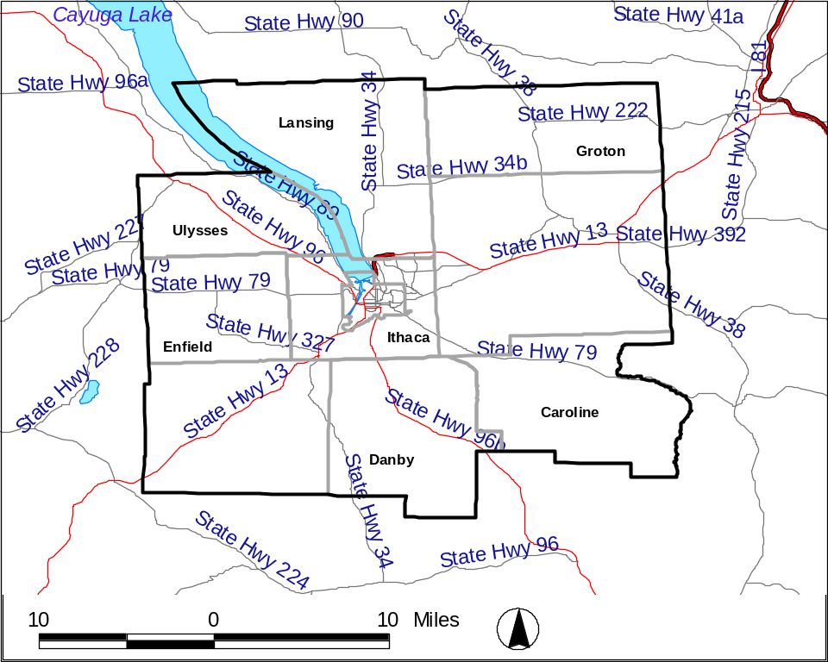
Source: HAZUS-MH (FEMA 2004)

Figure 4-2-12. Locations Where Roadways Transect Water Supply Areas in Tompkins County
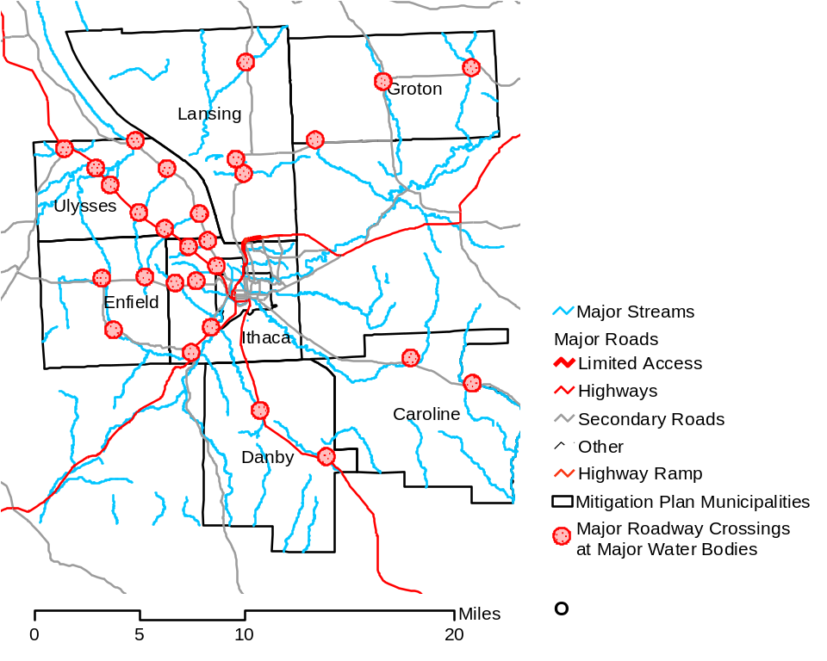
Source: HAZUS-MH (FEMA 2004)

Figure 4-2-13. Locations Where Railroad Lines Transect Water Bodies

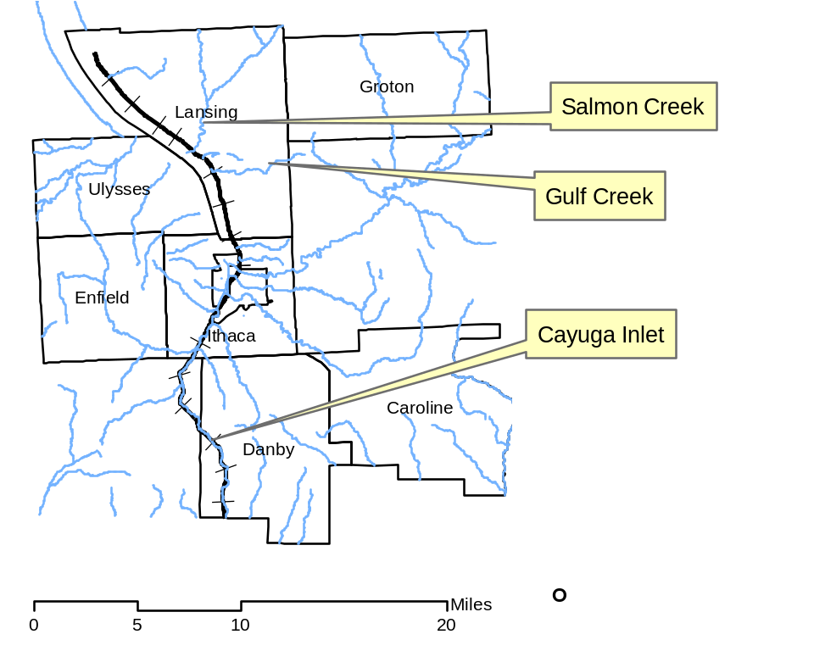
Source: HAZUS-MH (FEMA 2004)
4.2.3.2 Water Supply Contamination

HAZNY Summary of Risk Factors |  | Profile Ranking
Potential Impact: | Large region
Onset: | No warning
Frequency: | Infrequent event
Hazard Duration: | More than 1 week
Cascade Effects: | Some potential
Recovery Time | 1 to 2 days

Water Supply Contamination HAZARD PROFILE
Background and Local Conditions
Approximately 50 percent of Tompkins County residents utilize private wells for their drinking water, while the remaining half of Tompkins County residents rely on one of three drinking water treatment plants to supply their drinking water: the Cornell drinking water treatment plant (WTP), the City of Ithaca drinking WTP, and the Bolton Point WTP. These plants withdraw water from Fall Creek, Six Mile Creek, and Cayuga Lake, respectively. Intentional or unintentional contamination of these water supplies is of particular concern because of the number of people that rely on each system and the fact that surface water resources are relatively easily contaminated (Tompkins County 2003e). Additionally, municipal wells in Groton and Danby are sources for ground water used for public water distribution. Potential situations that could impact the water supply of Tompkins County include:
- Physical damage to water supply or delivery systems (breaks in pipes, landslides that block water supply intakes, water treatment etc.)
- Hazardous material releases, spills, and leaks that reach surface water supplies or drinking water aquifers
- Terrorist acts that contaminate the supply
- Bacterial contamination, such as E. coli
- Mechanical problems with the WTP operations (e.g., breakdown of equipment) that disrupt or hinder the timely and safe delivery of clean water
Table 4-2-4 identifies the source of water and number of people served by the water supply systems within the Tompkins County study area. Figure 4-2-14 shows the sources and locations of water treatment facilities.

Approximately half of Tompkins County residents rely on groundwater for their drinking water (including individual wells and community and municipal systems). Close to 185 wells exist in the study area. Groundwater in Tompkins County is predominantly from bedrock and unconfined aquifers. Contamination of wells by chemicals and bacteria is a concern for residents as bedrock and unconfined aquifers are highly susceptible to contamination from spills, herbicide and pesticide runoff, and leaking underground storage tanks. Because bedrock geology is complex, it is often difficult to find alternate water supplies once one is contaminated. Table 4-2-4 summarizes potable water data for Tompkins County.

Historic Frequency and Probability of Occurrence
Several instances of contamination to the municipal water systems in the Tompkins County study area have been recorded, including:
1997 – Fuel oil spill caused a water supply outage at the Cornell WTP for 6 days.
Prior to 1981 – Both the City of Ithaca and Cornell’s WTPs have been shut down due to high turbidity and fuel oil spills.

With respect to the probability of water contamination hazard events, the HAZNY report resulted in a frequency description term of an “infrequent event” for water supply contamination. The ground rules for the program quantify this descriptor as an event that occurs between once every 8 years and once every 50 years. This type of hazard is impossible to accurately predict; however, historic review of location of transportation accidents that resulted in water contamination and identification and study of areas prone to traffic accidents near water bodies (for example, see Figure 4-2-12 which identifies transportation routes that intersect water bodies in Tompkins County) can assist in determining the potential location of future events. More stringent environmental regulations and mapping of leaking underground storage tanks could assist in determining hazard areas, and in identifying mitigation activities to decrease the likelihood of future events. Based on the historic data and HAZNY results, it is estimated that a water supply contamination event of magnitude could occur once every 15 years (though members of the planning group believe that the possible frequency of such an event is greater than indicated by HAZNY).
Severity
Serious injury or death from water contamination based on historic events is unlikely. Moderate damage would occur to private property, while little to no structural damage would result to public facilities (Tompkins County 2003e).
Historic Losses and Impacts
In Tompkins County, several incidents of groundwater contamination have resulted from leaking underground storage tanks and industrial and commercial spills. The Village of Groton water supply was threatened by a spill associated with Smith Corona. The well water of several homes in Jacksonville, located in the Town of Ulysses, were impacted by methyl-t-butyl ether (MTBE) and other gasoline-related constituents that began approximately 30 years ago (Tompkins County 2003F). These residents had to use bottled water until they were connected to the Bolton Point water system in April of 2004. The Town of Danby also reports occasional incidences of leaking underground storage tanks, but these have occurred in areas with no public water. The Shelter Valley water system (in the Town of Newfield) has a history of water supply contamination issues, including numerous do-not-drink orders issued by the Tompkins County Health Department (Tompkins County 2003e). The hazardous materials response database of the National Response Center (NRC), a department of the U.S. Coast Guard that records responses and incidents involving hazardous materials releases for the U.S., lists several incidents involving spills to surface water and land from fixed and mobile sources in Tompkins County since 1990. None of the incidents reported in the database appear likely to result in widespread contamination.
Designated Hazard Areas
Hazard areas include all areas that receive their water from the three WTPs. In addition, the water bodies that provide water to the WTPs, especially areas adjacent to the WTP intakes, are of concern because impacts to them could result in impacts to drinking water delivered by the affected system. Areas where the groundwater is shallow or easily infiltrated by industrial or other forms of contamination are also vulnerable (see Figure 4-2-14).

Table 4-2-4. Potable Water Supply Data
System | Population Served | Water Source
Bolton Point WTP | 30,000 | Cayuga Lake (surface water)
City of Ithaca WTP | 35,000 | Six Mile Creek (surface water)
Cornell WTP | 27,000 | Fall Creek (surface water)
Village of Groton | 2,500 | Wells / infiltration gallery
Village of Trumansburg | 2,300 | Wells
Village of Newfield | 2,000 | Wells
West Danby | 270 | Wells
Data provided by Tompkins County Health Department (2004)
Notes: WTP – Water treatment plant

Figure 4-2-14. Water Supply and Water Treatment Facilities for Multi-Jurisdictional Study Area

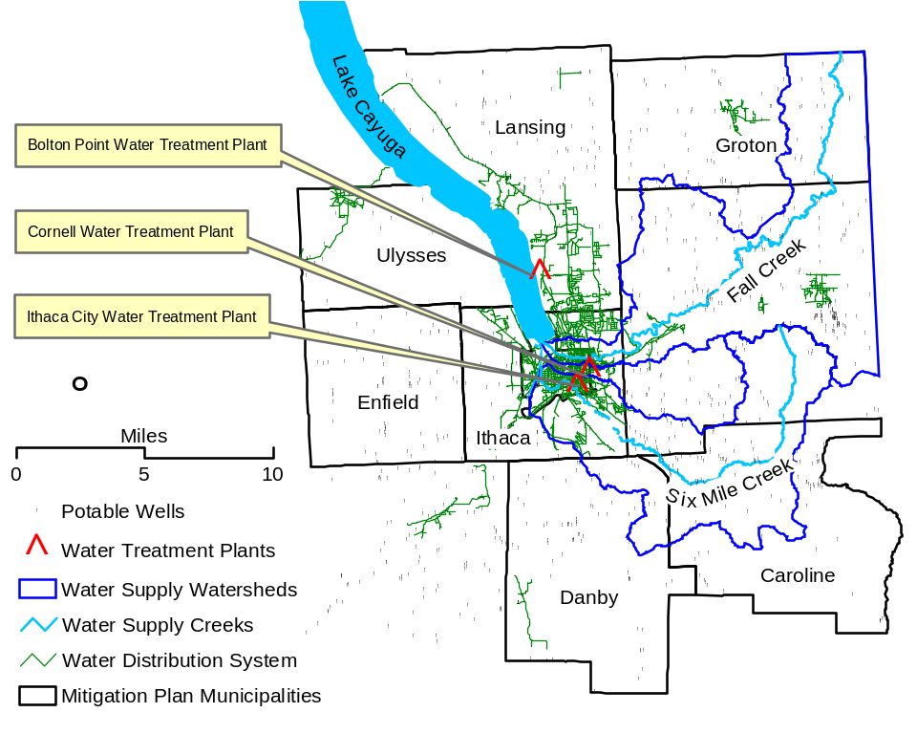
Source: HAZUS-MH (FEMA 2004)
4.2.3.3 Terrorism

HAZNY Summary of Risk Factors |  | Profile Ranking
Potential Impact: | Large impact region
Onset: | No warning
Frequency: | Infrequent event
Hazard Duration: | Varies greatly
Cascade Effects: | Highly likely
Recovery Time | More than 2 weeks

TERRORISM HAZARD PROFILE
Background and Local Conditions
Terrorist activities are by design difficult to predict, and intended to cause psychological impacts to large, far-reaching populations of people. Terrorist attacks can take many forms and affect multiple targets and sectors. Terrorist events have not been reported in Tompkins County; however, due to the presence of Cornell University, a high profile institution of cultural, social, and political significance located in the City of Ithaca and Town of Ithaca, Tompkins County may be more susceptible to a terrorist attack than other communities of Upstate New York (note: the City of Ithaca is not within the scope of this mitigation plan). Cornell University is home to state-of-the-art research facilities that support a vast array of research activities in medicine, science, and policy. The university could thus be considered both a potential target of a terrorist attack as well as a potential originating point for a terrorist attack (City of Ithaca 2003). Other features located within the Tompkins County study area that could be subject to terrorist attack include surface water supplies, water storage tanks, dams, power generation facilities, natural gas and petroleum pipelines, and the airport (see Table 4-2-5). Utilities are also subject to terrorist attack. Data on utilities is included in Section 4.3 of this plan.

Terrorism is a unique hazard that is of high national and international priority. Unlike most other hazards evaluated in mitigation plans such as this one, funds are available from multiple federal and state programs to counties and municipalities for terrorism response, mitigation, and prevention programs.
Historic Frequency and Probability of Occurrence
During the past decade, 12 incidents deemed terrorist in nature have occurred in America. However, no terrorist events have been recorded in Tompkins County. Cornell University received anthrax threats concurrent with the national anthrax episode following the events of September 11, 2001 (Tompkins County 2003e).

With respect to the probability of future terrorist hazard events, the HAZNY report resulted in a frequency description term of an “infrequent event” for terrorism. The ground rules for the program quantify this descriptor as an event that occurs between once every 8 years and once every 50 years. This type of hazard is impossible to accurately predict, however areas more vulnerable to terrorist activity include water supplies, large water and chemical storage tanks, dams, power generating facilities, natural gas and petroleum pipelines, and airports. Tompkins County will continue to take the necessary precautions to reduce the probability of an event and to ensure the safety of its citizens.

Severity
Due to the current political climate of the world, the often horrific and murderous outcomes of terrorist attacks, and the wide-reaching effects of terrorist acts, terrorism is considered a moderate hazard, even though no historic record exists in Tompkins County. Few, if any, of the facilities, lifelines, or critical facilities in Tompkins County and the municipalities were designed to withstand or prevent a large-scale terrorist attack. The timing of a terrorist attack would have a large impact on the outcome; an attack during the day, when roads and facilities are busy would likely be more damaging than a similar event conducted during the evening when most people are in their homes. The severity of a terrorism event is significant should an event occur at a critical facility. In particular, the municipality of Lansing is highly susceptible to a terrorist event because the AES Cayuga power generating facility and the Ithaca-Tompkins Regional Airport are both located in this town. Additionally, the three main surface water supplies for Tompkins County are in the study area (See the profile for water supply contamination in Section 4.2.3.2). Several dams are located within the study area that if damaged could cause significant impacts, including flooding.
Historic Losses and Impacts
No historic losses have been related to terrorist attack in Tompkins County; however, estimates can be made based on events that have occurred at other locations in the country that would indicate terrorism should be a high priority hazard (Tompkins County 2003e). Tompkins County assumes the impact of terrorism upon the study area could include serious injury or death for extremely large numbers of people, moderate damage to private property, and moderate structural damage to public facilities (Tompkins County 2003e.)
Designated Hazard Areas
Given the potential magnitude of the damage and loss of life that could result from a contemporary terrorist attack, substantial planning and counter-terror efforts are in progress throughout the United States at the federal, state, and local levels. The Ithaca Police Department maintains a computer system linked to the New York State Anti-Terrorism Network. Hazard mitigation policies at the local level will strengthen the effectiveness of the counter-terror efforts of the state (City of Ithaca 2003). Due to the proximity to the City of Ithaca, the Town of Ithaca may be considered a terrorism hazard area. Table 4-2-5 identifies critical facilities in the study area that could be targets for a terrorist attack. As this table demonstrates, the Town of Lansing may be particularly susceptible to terrorism, as it houses several critical facilities. Terrorist activities involving pipelines are particularly troublesome in areas where pipelines are exposed or buried close to the surface. Such areas exist in the Town of Danby, where two pipelines intersect (north of Stork), and at a facility west of Ridgecrest Road.

Table 4-2-5. Potential Terrorist Targets in the Study Area
Feature | Municipalities (# Features)
Surface Water Supplies | Towns of Lansing and Ithaca
Dams | Towns of Caroline, Danby, Lansing and Ithaca
Airports | Town of Lansing (1)
Power Generation Facilities | Town of Lansing (1)
Pipelines (Natural Gas and Petroleum) | Countywide (see Utility Failure Hazard Profile - Section 4.2.2.1)
Source: Tompkins County GIS Department and HAZUS-MH (FEMA 2004)
4.2.3.4 Civil Unrest

HAZNY Summary of Risk Factors |  | Profile Ranking
Potential Impact: | Several individual locations
Onset: | More than one week warning
Frequency: | Frequent event
Hazard Duration: | More than 1 week
Cascade Effects: | Some potential
Recovery Time | Less than 1 day

CIVIL UNREST HAZARD PROFILE
Background and Local Conditions
Although public demonstrations are not uncommon in Tompkins County, most are peaceful and without acts of vandalism or violence. Most incidences of civil unrest in Tompkins County are linked to the activities of Cornell University and Ithaca College students, including Cornell University’s Slope Day and Ithaca College’s Fountain Day. These two student-related activities (as well as the most popular student parties that occur predictably at the beginning and end of each academic semester), tax police, emergency medical and fire services. Emergency response professionals also must prepare for civil unrest situations that might arise from the annual Grassroots Festival (in the Town of Ulysses) and local sporting events (Tompkins County 2003e).
Historic Frequency and Probability of Occurrence
The only recorded incidents in Tompkins County in which protest activities resulted in unlawfulness involve a student take-over of Cornell University’s Willard Straight Hall in the late 1960s and a demonstration in the Town of Dryden regarding the unethical treatment of animals.

With respect to the probability of future civil unrest hazard events, the HAZNY report resulted in a frequency description term of a “frequent event” for civil unrest. The ground rules for the program quantify this descriptor as an event that occurs more than once a year. This type of hazard is impossible to accurately predict; however, most incidences of civil unrest in Tompkins County are linked to the activities of Cornell University and Ithaca College students, including Cornell University’s Slope Day and Ithaca College’s Fountain Day (which occur annually). Based on historical information it is estimated that Tompkins County will continue to experience some civil unrest if these traditions and the Grassroots Festival continue.
Severity
Taking into account historical events, the Tompkins County HAZNY Report states that a civil unrest event will not likely cause serious injury or death, and will result in little or no damage to infrastructure.
Historic Losses and Impacts
No data to date.
Designated Hazard Areas
Historical records place civil unrest events, such as protests, in certain locations, mainly the campuses of Cornell University and Ithaca College (not included in this plan’s study region), and the location of the Grassroots Festival in the Town of Ulysses. Other typical areas of protest may be the respective town halls. Figure 4-2-15 includes the location of each town’s municipal building, the two colleges, and the Grassroots Festival, all locations where civil unrest may be a particular hazard.

Figure 4-2-15. Potential Hazard Areas for Civil Unrest in Tompkins County Multi-Jurisdictional Study Area

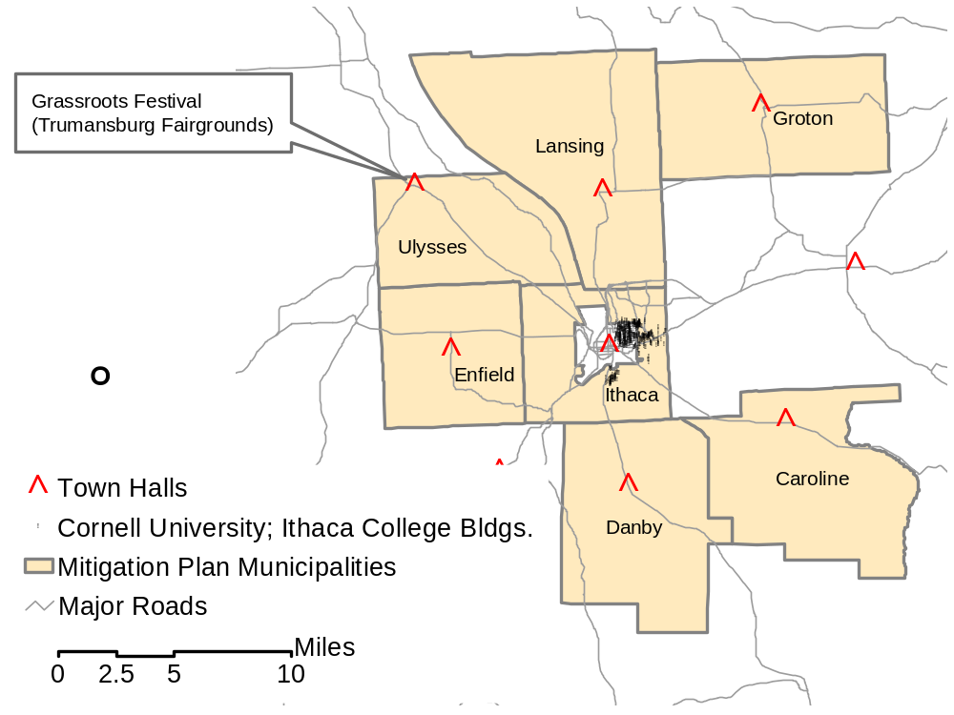
Source: Tompkins County GIS data

